**Lab 4: Karnaugh Maps**

Freddie Boadu

ECEN 328

Mansi Bhavsar

March 21,2019

**Introduction:** The overall objective/purpose of this lab is getting students comfortable with the application and use of a Karnaugh Map or (Kmap). The Kmap is used to simply Boolean equations into the least expensive form. The more variables involved the most expensive a circuit becomes. Kmaps are meant to reduce the amount of cost as well as make the circuit as simple as possible. Kmaps consist of a box subdivided into rows and columns. The cells are then assigned numbers based on the number of bits present. For example, this is how a 3-bit kmap would look: 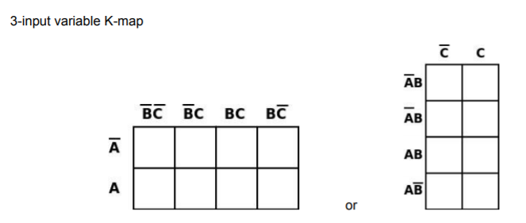

The maps are used to obtain a minimum sum of products but grouping the 1’s that are displayed on the map certain ways. This lab was meant to reinforce those ideals and make the student feel more comfortable with the concept.

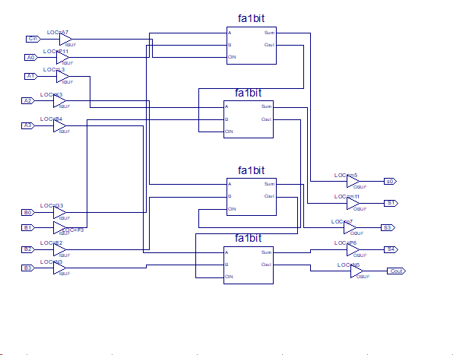**Methods:**

The student was to open a new project called Karnaugh. The student was asked to make a truth table based on the truth table provided in the second section of the lab. The truth table looks like this: 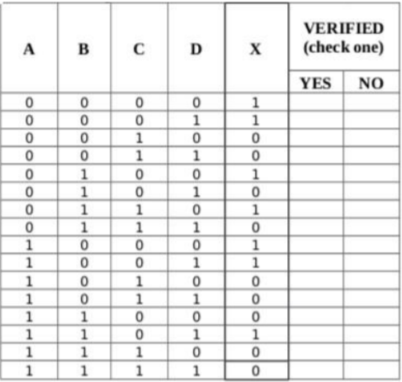

Once the student has verified that the truth table is correct on their board they were asked start to make a Kmap based off the truth table that had been verified. The student found that the Boolean expression when from A’B’C’D’+ A’B’C’D+ A’BC’D’+ A’BCD’+ AB’C’D’+ AB’C’D+ ABC’D to B’C’+A’BD’+AC’D.

The students were asked to make schematics of them both which will be posted in the data section.

**Data:**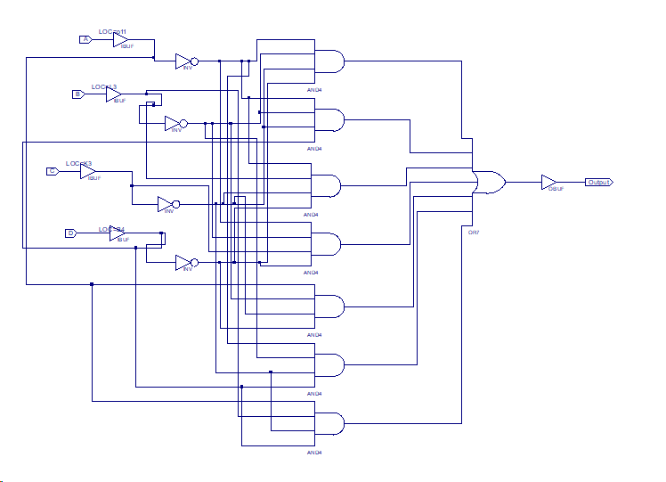

Part 1 schematic of: A’B’C’D’+ A’B’C’D+ A’BC’D’+ A’BCD’+ AB’C’D’+ AB’C’D+ ABC’D

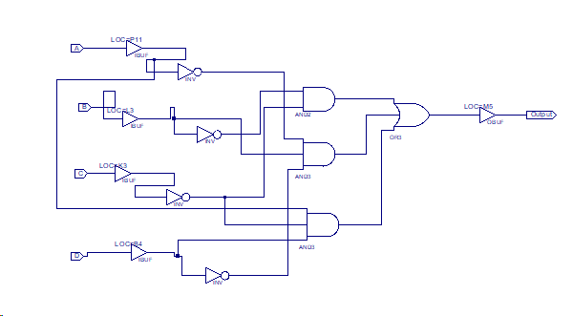

Simplified part 1 schematic using a kmap

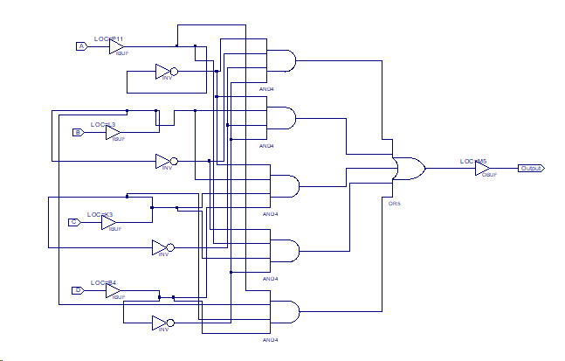

Design challenge part A

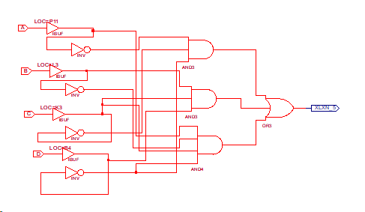

Design challenge part B

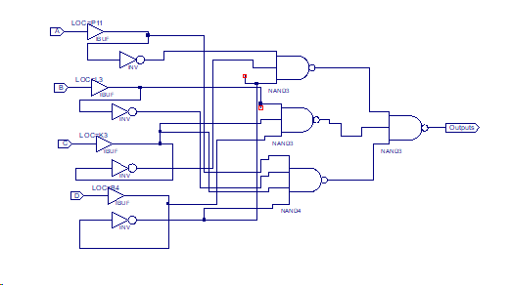

Design challenge Part C

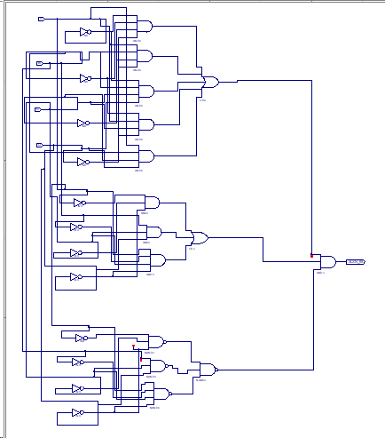

Design Challenge Part D

**Results and Discussions:** The schematics show the relationship between the original equations and their sop after a Kmap. For example, Part 1 and Part 2 schematics yield the same exact truth tables. Part 2 is just a short less expensive circuit which makes Kmaps extremely useful for cutting down the complexity of a circuit. The student can put the two schematics side by side and test whether this is true further proving that point.

**Design challenge**:

The student was required to make 4 different schematics for the design challenge. Part A was based on the original equation: A’B’C’D’+ A’BC’D’+ A’BCD+ AB’CD’+ ABCD. The schematic in the data is labeled and represented. The student was then asked to simplify the equation done in part A using a Kmap. The equation was found to be A’C’D’+ BCD+ AB’CD’. This is represented through part B in the data as labelled. For part C the student was asked to represent the equation using only NANDS and NORS. This required that the student must do a double demorgans to the equation to put it in the correct form of A’C’D’* BCD* AB’CD’. Then for the final part of the challenge the student had to combine all three schematics in an AND gate in other to make sure the circuit compares the three previous circuits for all possible inputs and generates an output of high when they are equal and low when they aren’t equal. This required a large schematic that is seen in the data.

**Conclusion:** The experiment above shows the use and important of Kmaps in terms of circuit design. This experiment required the students to use Kmaps to reduce equations to the simplest forms and implement them. This allowed them to be compared. The experiment helped the students to also learn the relationship between a Kmap and the truth table it represents.